**System response by different inputs in matlab and Simulink**

**Lab report #02**



Fall 2022

CSE-310L Control Systems

Submitted by: **Ashfaq Ahmad**

Registration No: **19PWCSE1795**

Class Section: **B**

“On my honor, as student of University of Engineering and Technology, I have neither given nor received unauthorized assistance on this academic work.”

Student Signature: ______________

Submitted to:

**Dr: Muniba Ashfaq**

**Oct** 17, 2022

**Department of Computer Systems Engineering**

**University of Engineering and Technology, Peshawar**

**Task01:** Find the impulse response and step response of the following system by using matlab also use Simulink and then compare both results.

G(s)=100/s^2+4s+20

**Source Code**:

clc

clear all

close all

num=100;

denum=[1,4,20];

sys=tf(num,denum); %when impulse input is passed from a system change in output is called impulse response.

im=impulse(sys); %when step input is passed from a system change in output is called step response.

st=step(sys);

plot(im);

title('Impulse Response');

grid on

figure

plot(st);

title('Step response');

grid on

**Impulse Response:**



**Block Diagram of unit response:**

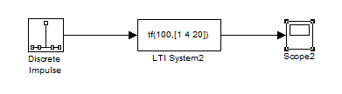

**Graph:**

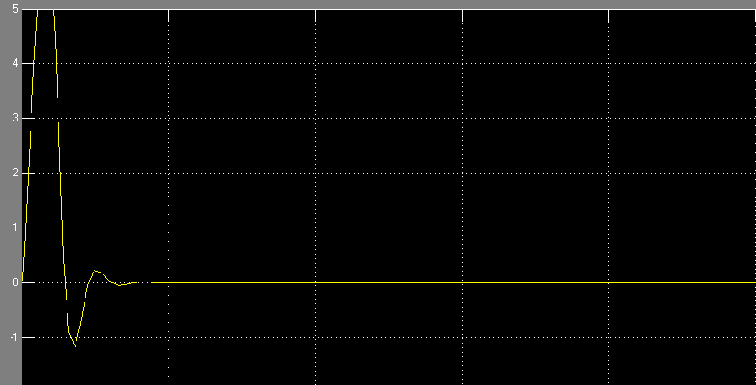

**Step response:**



**Block Diagram of step response:**

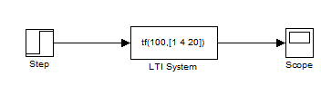

**Graph:**

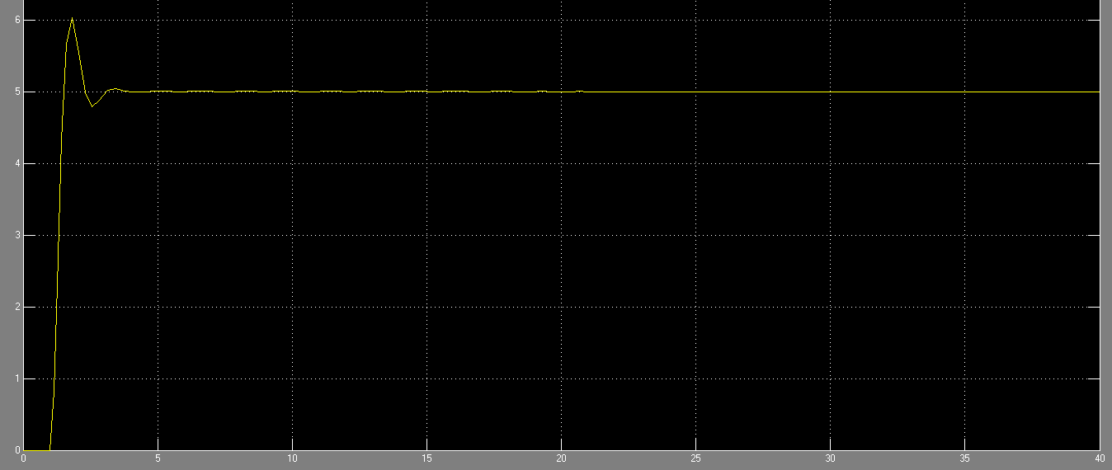

***Note:*** *impulse is the derivative of step response.*

**Task02:** Also apply sinusoidal input.

**Source Code:**

clc

clear all

close all

t=0:0.01:10;

u=sin(t);

num=100;

denum=[1 4 20];

sys=tf(num,denum);

y=lsim(sys,u,t);

%lsim: gives the time response of LTI system to arbitrary inputs.

%u is arbitrary input.

%t is time span.

plot(y);

title('sinusiodal Response');

grid on

**Sinusoidal Response:**



**Block Diagram of sinusoidal response:**

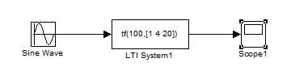

**Graph:**

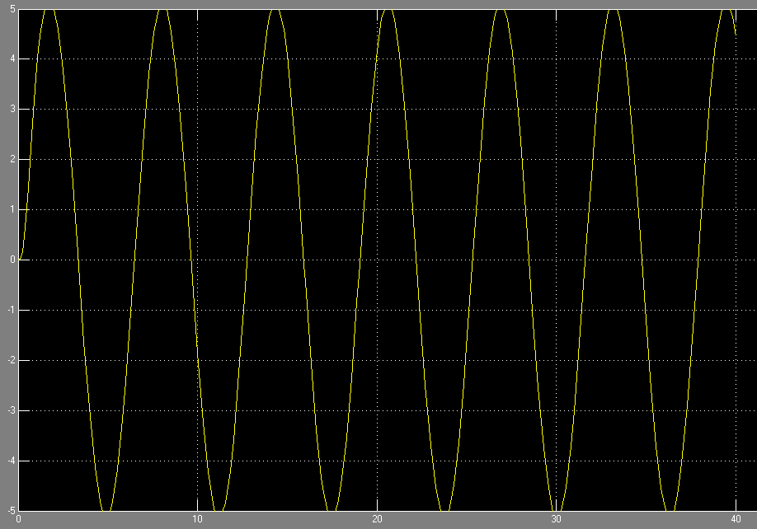

**Task03:** find system response to the input=sin (2*pi*t) +u (t) + 2u (t-5)

**Source code:**

clc

clear all

close all

t=0:0.01:10;

u=sin(t);

num=100;

denum=[1 4 20];

sys=tf(num,denum);

y1=lsim(sys,u,t); %sin response

y2=step(sys,0:0.01:10); %unit step response

y3=step(sys,5:0.01:10); %unit step response

temp=zeros(500,1);

y3=[temp;y3]; %b/c the size of y3 become = to y1 and y2.

y=y1+y2+2*y3;

plot(y);

Graph:



**Block Diagram:**

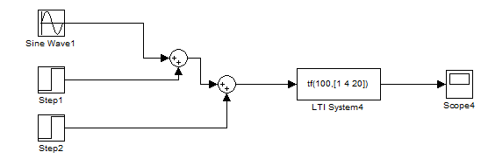

**Graph:**

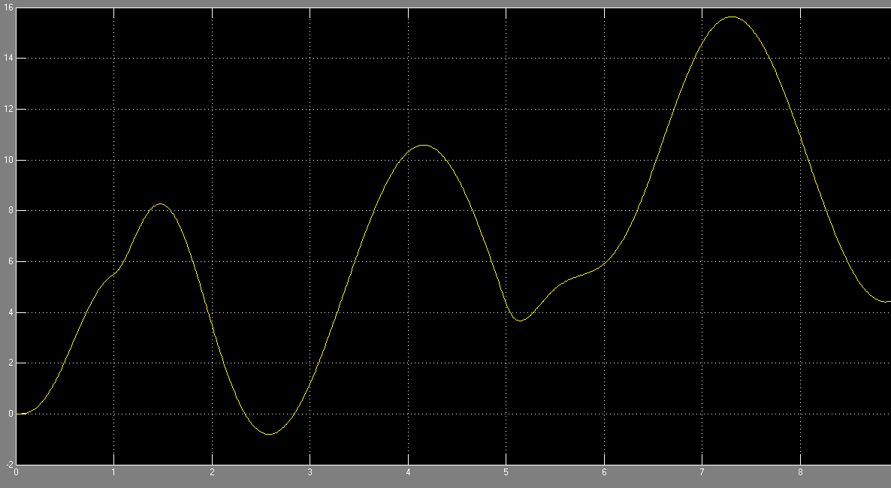

**Task04:** Square input with amplitude equal to 2 and time period equal to 10. Simulate the system for 40 seconds.

**Source code:**

clc

clear all

close all

t=0:0.01:40;

sq=2*square(t);

num=100;

denum=[1,4,20];

sys=tf(num,denum);

y=lsim(sys,sq,t);

plot(y);

**Graph:**



**Block Diagram of square Function:**

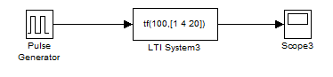

**Graph:**

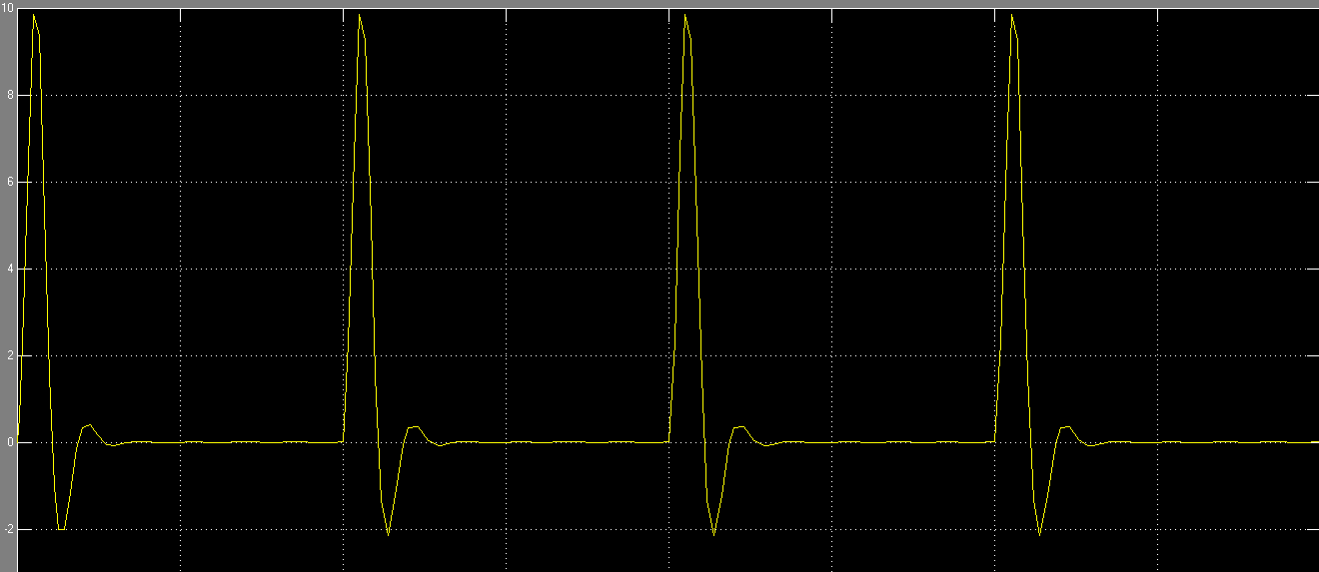

**Task05:** combine input from Q3 and Q4.

**Source Code:**

clc

clear all

close all

t=0:0.01:10;

u=sin(t);

num=100;

denum=[1 4 20];

sys=tf(num,denum);

y1=lsim(sys,u,t);

y2=step(sys,0:0.01:10);

y3=step(sys,5:0.01:10);

temp=zeros(500,1);

y3=[temp;y3];

yA=y1+y2+2*y3;

sq=2*square(t);

yB=lsim(sys,sq,t);

result=yA+yB;

plot(result);

**Graph:**



**Block Diagram:**

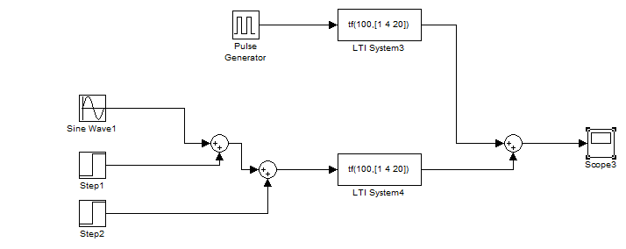

**Graph:**

